**NAME: Abhishek Tiwari**

**PRN: 121AX060**

# CLASS: B.E (CSE-IOT) BATCH: H3

**EXPERIMENT 2**

**AIM: Create a branch and perform various commands. THEORY:**

Git branches are effectively a pointer to a snapshot of your changes. When you want to add a new feature or fix a bug—no matter how big or how small—you spawn a new branch to encapsulate your changes.

The diagram here visualizes a repository with two isolated lines of development, one for a little feature, and one for a longer-running feature. By developing them in branches, it’s possible to work on both in parallel and keep the main branch free from questionable code.

The implementation behind Git branches is much more lightweight than other version control system models. Instead of copying files from directory to directory, Git stores a branch as a reference to a commit. In this sense, a branch represents the tip of a series of commits—it's not a container for commits. The history of a branch is extrapolated through the commit relationships.

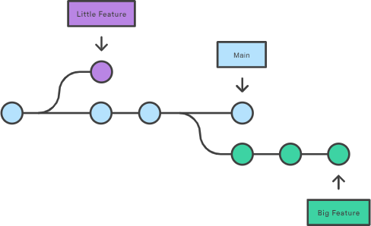

# STEPS AND OUPTUT:

1. Create a local repo under the main folder in visual studio using **mkdir local repo**

Eg Sample(main folder)-→ devops (sub folder), and localrepo(subfolder)

1. In localrepo create **2 files eg. Index.html and style.css**

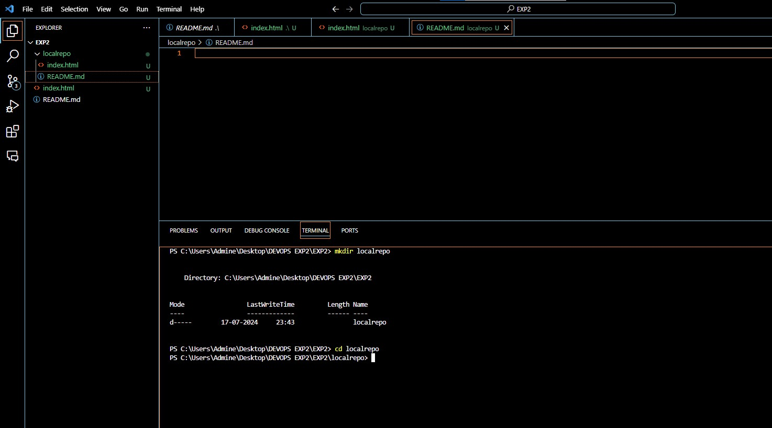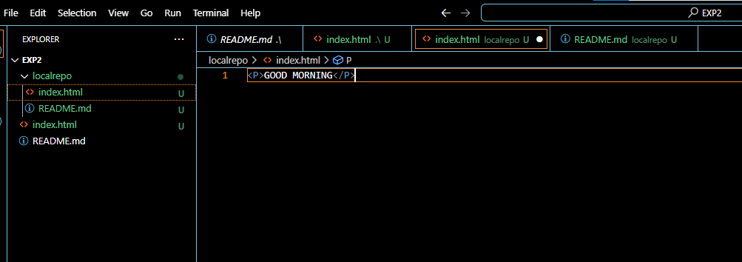

1. Go to local repo folder and use command **git init** (this makes it a git repository )

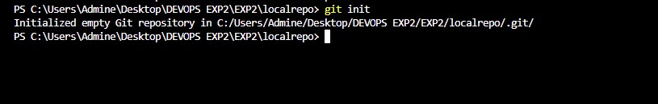

1. Now **git add .**
2. **git commit -m “files inserting”**
3. **git status**
4. Now go to your github account and create a respository without Readme.md file name it as localrepo.

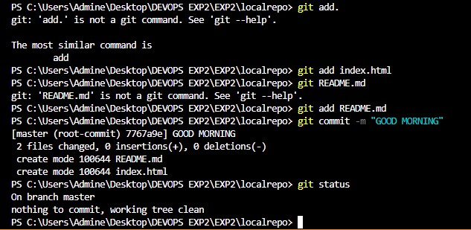

1. **git remote add origin “link of local repo created on github”** (this tells us that we are going to add new remote repo i.e setting the localrepo as new origin)
2. **git remote -v** (to verify remote)

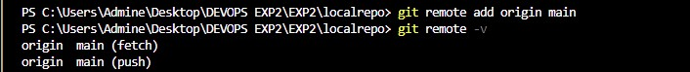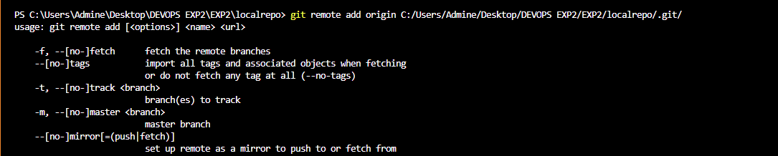

1. **git branch** (to check which branch are we working in)
2. if this shows main the make no changes
3. if it shows master(default branch) then change the branch to main by following command

**git branch -M main**

1. **git push origin main OR**

**Git push -u origin main** (-u meaning setting upstream, means if we are working the same project for long time always saying origin main origin main everytime in the same repo)

Next time when we make changes in the same repo we can just write **git push**

1. Workflow when we are working on local git (visual studio)

**Create Github repo**→**clone**→**make changes**→**Add**→**commit**→**Push**

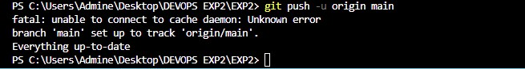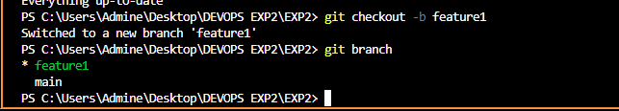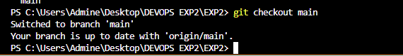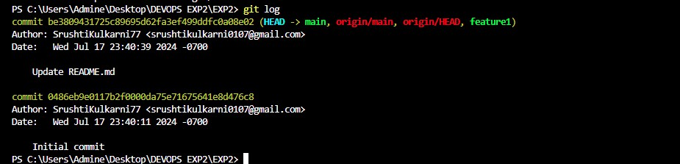

# CONCLUSION:

Thus, we have created git branch and performed various other commands using git.